Note:- when you run kivy apps from pycharm…you need to install kivy packages as below without dev.
Filesettingproject:kivy_basicsprojecct interpreter click or + symbol on right hand side and search for ‘kivy-dep’ and install the dependencies without dev versions.
About kivy:- https://github.com/kivy/kivy/wiki#mobiles
Youtube video for basics:- https://www.youtube.com/watch?v=wQQ0sUI2lJo
Github link for code:- https://github.com/inclement/kivycrashcourse
I am following below link to biuld Andriod/windows/linux app using python.
https://kivy.org
Note:- To make widows executable app. We need pyinstaller
To make Andriod app. We need buildozer to be installed to build Andriod files(.apk) windows won’t support. So we need to build using linux/ubuntu. I document below how to build andriod app with buildozer.
http://inclem.net/2014/01/12/kivy-crash-course/2_building_an_android_apk/
sample code link http://inclem.net/2019/12/18/kivy/kivy_tutorial_009_finishing_the_drawing_app/
code samples:- http://inclem.net/pages/kivy-crash-course/
check this link for more details about kivy guide https://kivy.org/doc/stable/guide/basic.html
To Check python version,
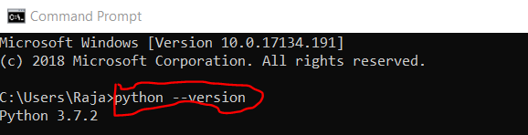
To install virtual environment,
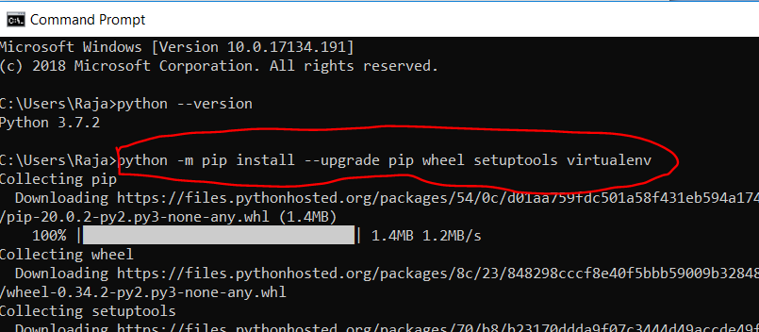
Creating separate virtual environment for kivy as below and install kivy inside kivy_venv. All related to kivy will be under kivy_venv fodler(which is virtual environment.) need to activate the virtual environment to work in the virtual environment. See below screen shot for refrence.
I follwed to install kivy on windows:- https://kivy.org/doc/stable/installation/installation-windows.html#install-win-dist
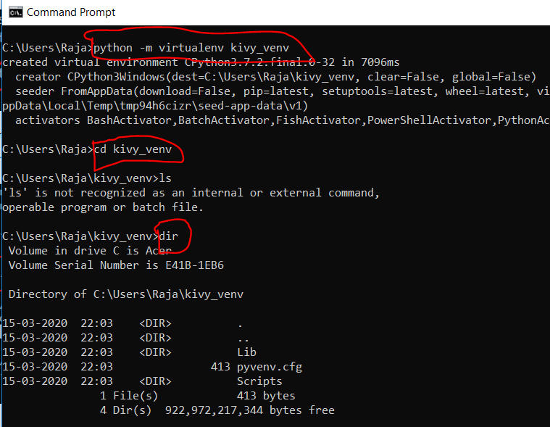
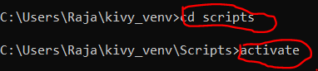
Installing the dependencies before installing Kivy software.
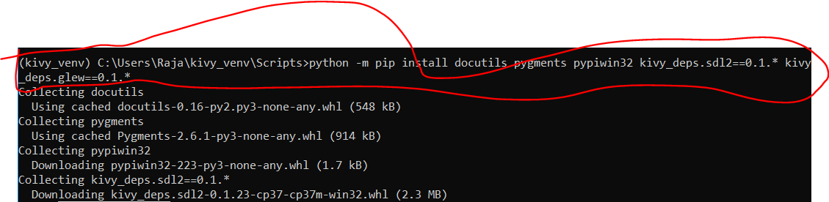
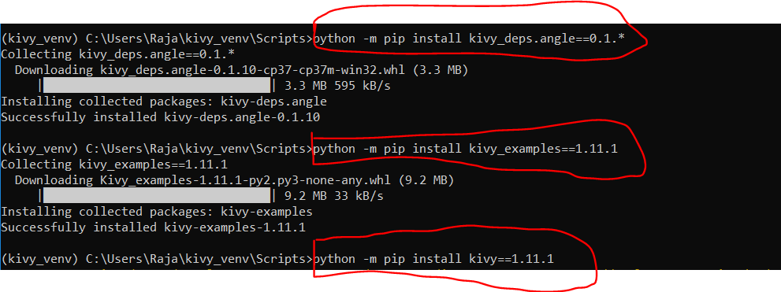
Simple example of kivy can be downloaded or installed using “ python –m pip install kivy-examples==1.11.1“
Below screenshot shows how to run example kivy app(animate.py code) on windows,
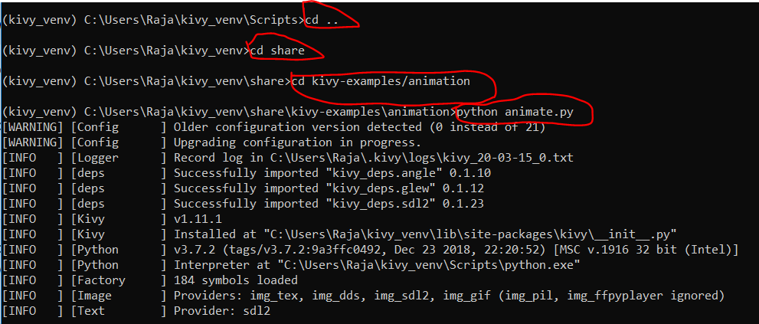

Installing Kivy on ubuntu 18.04
- Sudo add-apt-repository ppa:kivy-team/kivy
- Sudo apt-get update
- Sudo apt-get install python3-kivy
- Sudo apt-get install kivy-examples (once installed the files will present in /usr/share/kivy-examples)
Building Android file we use buildozer tool(which automatically download andriod toolchain when you perform ‘buildozer andriod debug deploy’ ). For this we need to install
Note:- I got error while building app. so, I install below dependencies
Sudo apt-get install automake autoconf libltdl-dev and ran ‘ buildozer android debug deploy’ and got llb error (need to install this If I get llb error ) .
I got no module named _ctypes error. So installed “ sudo apt-get install libffi-dev”. This time I used buildozer android clean and ran buildozer android debug deploy and it worked.
- Sudo apt-get install git (which is dependent for ‘buildozer andriod debug deploy’ to build andriod app)
- Sudo apt-get install cython (which is dependent for ‘buildozer andriod debug deploy’ to build andriod app)
- Sudo pip3 install buildozer or python3 –m pip install buildozer use 3 if you install python 3 versions…
- Go to your application folder where main.py file exists(which you want to convert as andriod app for phone) and type as below
Buildozer init (which will create buildozer.spec file which is nothing but config file need to update below variables in that file and save it. )
Title = 3Drender (give title name of your app)
Package.name = ThreeDrender (give name of the package. Here we should not use any numeric value.)
Version = 1.0
Requirements = kivy (by default it will contain python3, kivy. But I changed to kivy)
Orientation = all ( by default it will contain portrait. Means the app should turn or not based on mobile rotation.)
Fullscreen =0
Log_level = 2
- Then type buildozer andriod debug deploy (to build andriod app).
- Once step 5 completes .apk file presents in bin folder.
Note:- When you run buildozer, use the following command:
buildozer android debug deploy run logcat > log.txt
This will automatically save the logcat output to a txt file and you can figure out what's wrong from there. The log file saves python errors with the prefix [Python], so you can ctrl+F to find what the python exception is (if it is a python problem).
Use buildozer android clean to delete / clean build .apk . if you find any issue in mobile app and run buildozer android debug deploy
Simple Button program with python kivy:-
Logic to run the app
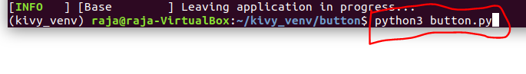
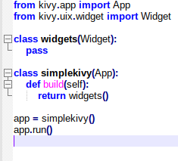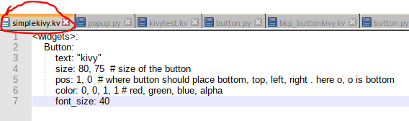
I wrote button logic in kivy language and the kivy file should be same as app (simplekivy) name then you can see the button in the app as shown below. We can also write button logic in python code without kivy language.

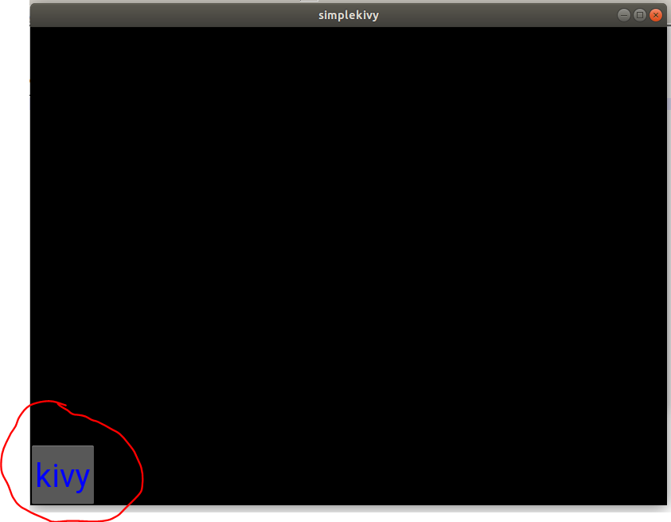
Note :- I saved kivy language file as button.kv app is working but button is not appearing. So, when you prefre to write the logic in kivy language you should save the file as app name.

Tpyes of Layout in Kivy:-
- BoxLayout
- GridLayout
- FloatLayout
- AnchorLayout
About color useage in kivy: - https://kivy.org/doc/stable/api-kivy.uix.label.html#kivy.uix.label.Label.color

Points to keep in mind while building multiple screens with any app including any of the screen,
- We need to call .kv file using Builder method and call this in app class
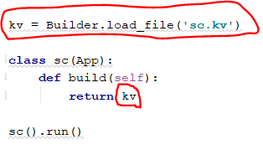
- Use uppercass while building class to use in .kv file
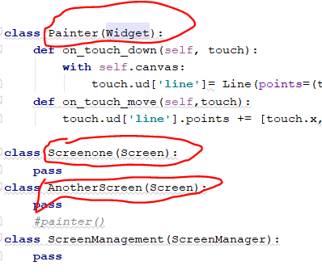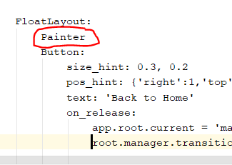
- Ful code of screen manager code with .kv file,

